The Spending Game
Purpose
Managing money means making choices. There is never enough money for all the things we want. This game will help you decide what is most important to you.

How to Play
Round #1:
Today, each of you has a “25 token” income.
Go through all the categories in “The Spending Game.”
Make at least one selection in each category, as appropriate, and spend your tokens accordingly.
Reflection Questions:
- What did you spend your money on?
- How do your values, goals, and past experiences affect spending choices?
- What did you learn about yourself from this activity?

Round #2:
Your income has been cut to 15 tokens.
Decide what you must give up.
Where will you cut the 10 tokens?
Reflection Questions:
- What was easy about choosing between options?
- What was difficult about choosing between options?
- What was the first item you gave up in Round #2?
- What was the last item you gave up in Round #2?
- What did you learn about yourself from this activity?

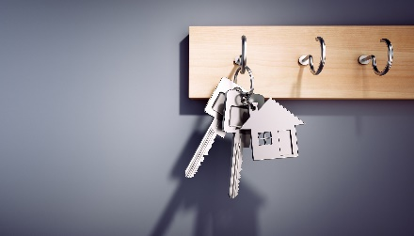

Housing expense: | # of tokens:
Live with family | 0
Share housing with roommates | 2
Rent place of your own | 3
Buy home | 4



Utilities expense: electric, gas heat, water, sewer, garbage | # of tokens:
Included in rent | 0
Cost shared with roommates | 1
You pay the bills for rental | 2
You pay the bills for your home | 3



Communications expense: | # of tokens:
No phone, Lifeline phone, public or free WiFi, or internet included in rent | 0
Cell phone | 1
Home internet | 2
Cell phone with unlimited data plan | 3


Furnishings expense: | # of tokens:
Borrow from friends or family | 0
Buy used | 1
Buy new | 2
Buy using rent-to-own financing | 3



Insurance expense: | # of tokens:
Healthcare coverage:
No coverage, or use family coverage up to age 26 | 0
Catastrophic coverage (under age 30 only) | 1
Lower premium plan (pay more when use services) | 2
Higher premium plan (pay less when use services) | 3
Auto coverage:
Liability coverage only | 1
Collision, comprehensive & liability (full coverage) | 2
SR-22 (high risk drivers) | 3
Renters & Homeowners coverage:
No coverage | 0
Renters insurance | 1
Homeowners insurance | 2

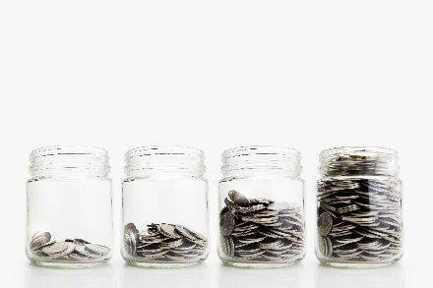

Savings: | # of tokens:
Regular deposits to savings account or prepaid card | 1
Retirement account contributions from paycheck | 2
Deposits into taxable brokerage account for investment purposes | 3



Food expenses: | # of tokens
Eat at home with family or take lunch to work | 1
Cook at home, eat out once per week | 2
Purchases at convenience stores & coffee shops | 3
Eat out frequently | 4



Transportation expenses: | # of tokens:
Walk, bike, or skateboard | 1
Public transportation | 1
Buy fuel for family car | 2
Ridesharing (Uber, Lyft) | 2
Buy used car | 3
Buy new car | 4


Recreation or entertainment: | # of tokens:
Outdoor activities or visit friends | 0
Recreation services & intramural sports | 1
Share TV, video or music streaming services with family | 1
Fitness membership | 2
Cable, satellite, or TV streaming services | 3
Night-out with friends or partners | 3
Movies, concerts, or sporting events | 3
Vacation travel (spring break) | 4

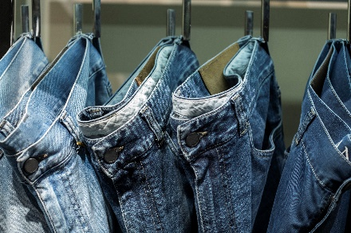

Clothing expenses: | # of tokens:
Clothing:
Wear clothing in closet or borrow from friends | 0
Buy at thrift or consignment stores | 1
Buy discounted clothing | 2
Buy full price, trendy clothing | 3
Laundry:
Use family washer & dryer or facilities included in rent | 0
Use laundromat | 1
Buy washer & dryer | 2


Personal care expenses: | # of tokens:
Basic haircut & generic hair products | 1
Cosmetics, teeth whitening or nutritional supplements | 2
Manicure or pedicure | 3
Hair salon services & products | 4



More spending choices: | # of tokens:
Regular giving to charities, tithing | 1
Music streaming services | 1
Gifts for friends & family | 2
Hobby or crafting | 2
Laptop or tablet device | 2
Gaming (pc or console) | 3
Sports betting | 3
Pet care & expenses | 3

